SWIGGY SALES ANALYSIS
BUSINESS REQUIREMENTS

Data Cleaning & Validation
The raw table swiggy_data contains food delivery records across states, cities, restaurants, categories, and dishes.
The first goal is to ensure data quality by performing:

Null Check
Identify missing values in:
- State
- City
- Order_Date
- Restaurant_Name
- Location
- Category
- Dish_Name
- Price_INR
- Rating
- Rating_Count

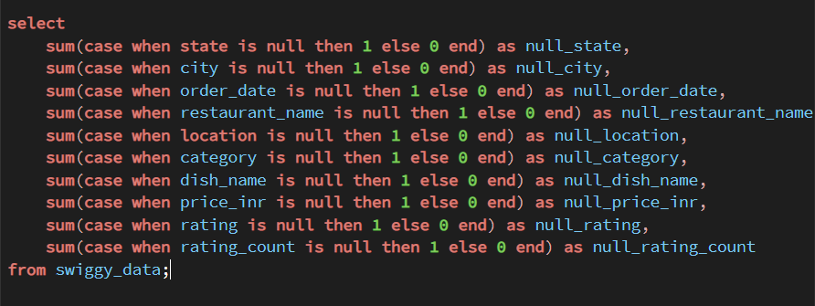

Blank/Empty String Check
Detect fields containing blank values that may cause inaccurate analysis.

select *
from swiggy_data
where state = '' or city ='' or restaurant_name = ''
or location ='' or category ='' or dish_name = '';

Duplicate Detection
Find duplicate rows using grouping on all business-critical columns.

select
state,order_date,city,restaurant_name,location,category,
dish_name,price_inr,rating,rating_count,
count(*) as CNT
from swiggy_data
group by
state,order_date,
city,restaurant_name,
location,category,
dish_name,price_inr,
rating,rating_count
having count(*) > 1;

Duplicate Removal
Use ROW_NUMBER() to delete surplus duplicate rows while retaining one clean copy for each unique order.

with CTE as (
select *, ROW_NUMBER() OVER(
PARTITION BY state,order_date,city,restaurant_name,
location,category,dish_name,price_inr,rating,rating_count
order by (select null)
) as rn
from swiggy_data
)
delete from CTE where rn > 1;

Dimensional Modelling (Star Schema)
Dimensional modelling helps organize data in a way that makes analysis simple, consistent, and extremely efficient. Instead of keeping all information mixed in one large table, the Star Schema separates descriptive information into dimensions and keeps all measurable values in a central fact table. This structure reduces data duplication, improves clarity, and makes the entire dataset easier to understand. It also supports faster reporting because queries can access small, focused tables rather than scanning a single bulky dataset. Most analytics and BI tools are designed to work best with star schemas, so this approach ensures smooth dashboard creation, accurate aggregations, and reliable insights. Overall, dimensional modelling provides a clean, scalable, and performance-optimized foundation for any analytical system, regardless of the industry or data source.
To optimize analytics and reporting, build a Star Schema with the following dimension tables:
- dim_date → Year, Month, Quarter, Week

CREATE TABLE dim_date(
date_id INT GENERATED ALWAYS AS IDENTITY PRIMARY KEY,
full_date DATE,
year INT,
month INT,
month_name VARCHAR(20),
quarter INT,
day INT,
week INT
);

- dim_location → State, City, Location

create table dim_location(
location_id INT GENERATED ALWAYS AS IDENTITY PRIMARY KEY,
state varchar(100),
city varchar,
location varchar
);

- dim_restaurant → Restaurant_Name

create table dim_restaurant(
restaurant_id INT GENERATED ALWAYS AS IDENTITY PRIMARY KEY,
restaurant_name varchar(100)
);

- dim_category → Cuisine/Category

create table dim_category (
category_id INT GENERATED ALWAYS AS IDENTITY PRIMARY KEY,
category varchar(100)
);

- dim_dish → Dish_Name

create table dim_dish(
dish_id INT GENERATED ALWAYS AS IDENTITY PRIMARY KEY,
dish_name varchar(200)
);

Central fact table:
- fact_swiggy_orders → Price_INR, Rating, Rating_Count, foreign keys to all dimensions
Populate each dimension with distinct data from the cleaned source and load fact table with all keys resolved.

CREATE TABLE fact_swiggy_data (
order_id INT GENERATED ALWAYS AS IDENTITY PRIMARY KEY,
date_id INT,
price_inr DECIMAL(10,2),
rating DECIMAL(4,2),
rating_count INT,
location_id INT,
restaurant_id INT,
category_id INT,
dish_id INT
);

ALTER TABLE fact_swiggy_data
ADD CONSTRAINT fk_date
FOREIGN KEY (date_id) REFERENCES dim_date(date_id);

ALTER TABLE fact_swiggy_data
ADD CONSTRAINT fk_location
FOREIGN KEY (location_id) REFERENCES dim_location(location_id);

ALTER TABLE fact_swiggy_data
ADD CONSTRAINT fk_restaurant
FOREIGN KEY (restaurant_id) REFERENCES dim_restaurant(restaurant_id);

ALTER TABLE fact_swiggy_data
ADD CONSTRAINT fk_category
FOREIGN KEY (category_id) REFERENCES dim_category(category_id);

ALTER TABLE fact_swiggy_data
ADD CONSTRAINT fk_dish
FOREIGN KEY (dish_id) REFERENCES dim_dish(dish_id);

ERD DIAGRAM: STAR SCHEMA

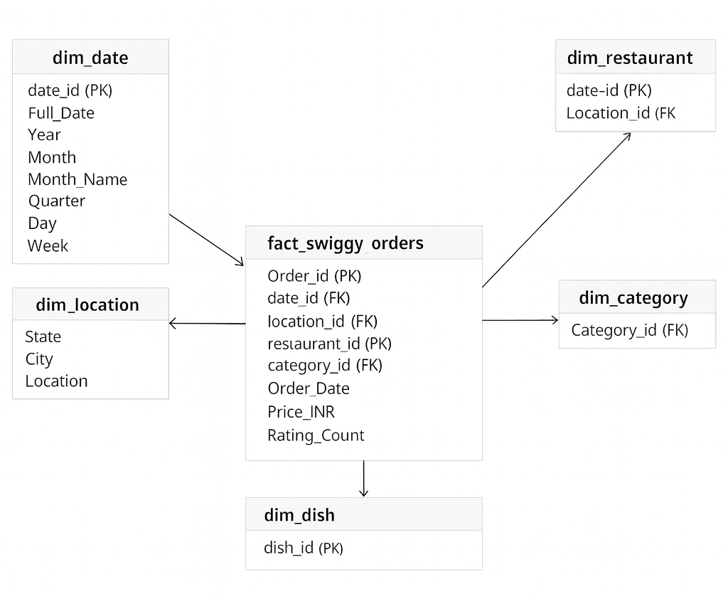

KPI Development
Once the schema is built, compute core performance indicators:
Basic KPIs
- Total Orders

select count(*) as Total_Order
from fact_swiggy_data;

- Total Revenue (INR Million)

select
round(sum(price_inr)/1000000.0 ,2) || ' Million INR' as Total_revenue
from fact_swiggy_data;

- Average Dish Price

select
round(avg(price_inr),2) || 'INR' as Average_Price
from fact_swiggy_data;

- Average Rating

select
round(avg(rating),2) as Average_rating
from fact_swiggy_data;

Deep-Dive Business Analysis
Date-Based Analysis
- Monthly order trends

select
d.year,
d.month,
d.month_name,
count(*) as Total_orders
from fact_swiggy_data f
join dim_date d on f.date_id = d.date_id
group by month_name,year,month
order by Total_orders desc;

- Quarterly order trends

select
d.year,
d.quarter,
count(*) as Total_Order
from fact_swiggy_data f
join dim_date d on f.date_id = d.date_id
group by year,quarter
order by Total_Order desc;

- Year-wise growth

select
d.year,
count(*) as Total_Order
from fact_swiggy_data f
join dim_date d on f.date_id = d.date_id
group by year;

- Day-of-week patterns

select
TO_CHAR(d.full_date, 'Day') AS day_name,
count(*) as Total_Order
from fact_swiggy_data f
join dim_date d on f.date_id = d.date_id
group by day_name;

Location-Based Analysis

- Top 10 cities by order volume

select
dl.city,
count(*) as Total_order
from fact_swiggy_data f
join dim_location dl on f.location_id = dl.location_id
group by dl.city
order by Total_order desc
limit 10;

- Revenue contribution by states

select
dl.state,
round(sum(price_inr)/1000000.0,2) || 'M INR' as Total_Revenue
from fact_swiggy_data f
join dim_location dl on f.location_id = dl.location_id
group by dl.state
order by Total_Revenue desc;

Food Performance

- Top 10 restaurants by orders

select
r.restaurant_name,
count(*) as Total_order
from fact_swiggy_data f
join dim_restaurant r on f.restaurant_id = r.restaurant_id
group by r.restaurant_name
order by Total_order desc
limit 10;

- Top categories (Indian, Chinese, etc.)

Select
c.category,
count(*) as Total_order
from fact_swiggy_data f
join dim_category c on f.category_id = c.category_id
group by c.category
order by Total_order desc
limit 10;

- Most ordered dishes

select
di.dish_name,
count(*) as Total_order
from fact_swiggy_data f
join dim_dish di on f.dish_id = di.dish_id
group by di.dish_name
order by Total_order desc
limit 10;

- Cuisine performance → Orders + Avg Rating
select
c.category,
count(*) as Total_order,
round(avg(rating),2) as Avg_rating
from fact_swiggy_data f
join dim_category c on f.category_id = c.category_id
group by c.category
order by Total_order desc
limit 10;

Customer Spending Insights
Buckets of customer spend:
- Under 100
- 100–199
- 200–299
- 300–499
- 500+
With total order distribution across these ranges.
Select
case
when price_inr < 100 then 'under 100'
when price_inr between 100 and 199 then '100-199'
when price_inr between 200 and 299 then '200-299'
when price_inr between 399 and 499 then '399-499'
else '500+'
end as price_range,
count(*) as total_order
from fact_swiggy_data
group by
case
when price_inr < 100 then 'under 100'
when price_inr between 100 and 199 then '100-199'
when price_inr between 200 and 299 then '200-299'
when price_inr between 399 and 499 then '399-499'
else '500+'
end
order by total_order desc;

Ratings Analysis
Distribution of dish ratings from 1–5.

select
rating,
count(*) as total_rating
from fact_swiggy_data
group by rating
order by rating;

